RESULTS
One hundred and twenty patients were randomly allocated into three equal groups (each 40 patient); group Ι (propofol TIVA), group ΙΙ (propofol-ketamine TIVA) and group ΙΙΙ (isoflurane inhalational anaesthesia). Each group was divided into two equal subgroups (each 20 patient); subgroups A (ΙA & ΙΙA & ΙΙΙA), where the hypnotic drug concentration (propofol or isoflurane) was adjusted to keep the BIS between 40 and 60 during surgery, and subgroups B (ΙB & ΙΙB & ΙΙΙB), where the hypnotic drug concentration was adjusted according to the standard clinical practice.
Demographic data:
There were no significant statistical differences between subgroup IA and subgroup IB as regard age ,sex ,weight and the durations of anaesthesia.
Table(7-1): Demographic characteristics in propofol subgroups (IA&IB )
 |  | N | Mean | Std. Deviation | t | P
Age (years) | Subgroup IA | 20 | 42.80 | 10.606 | 1.3 | >0.05
 | Subgroup IB | 20 | 37.90 | 12.794
Wt (Kg) | Subgroup IA | 20 | 76.75 | 7.656 | 1.2 | >0.05
 | Subgroup IB | 20 | 73.20 | 10.788
Duration of anaesthesia (Min) | Subgroup IA | 20 | 60.00 | 18.445 | 0.1 | >0.05
 | Subgroup IB | 20 | 59.50 | 17.695
Sex (male : female) | Subgroup IA | 11:9 |  |  | X² | P
 | Subgroup IB | 10:10 |  |  | 0.1 | >0.05
There were no significant statistical differences between subgroup ΙΙA and subgroup ΙΙB as regard age ,sex ,weight and the durations of anaesthesia.

Table(7-2):Demographic characteristics in propofol-ketamine subgroups (IIA &IIB)
 |  | N | Mean | Std. Deviation | t | P
Age(years) | Subgroup IIA | 20 | 39.35 | 11.389 | --- | ----
 | Subgroup IIB | 20 | 39.35 | 11.226
Wt(Kg) | Subgroup IIA | 20 | 74.50 | 9.720 | 0.2 | >0.05
 | Subgroup IIB | 20 | 75.00 | 9.177
Duration of anaesthesia(Min) | Subgroup IIA | 20 | 56.75 | 16.667 | 0.1 | >0.05
 | Subgroup IIB | 20 | 56.55 | 17.813
Sex (male : female) | Subgroup IIA | 12:8 |  |  | X² | P
 | Subgroup IIB | 11:9 |  |  | 0.1 | >0.05

Also,there were no significant statistical differences between subgroup ΙΙΙA and subgroup ΙΙΙB as regard age, sex, weight and the durations of anaesthesia.

Table(7-3):Demographic characteristics in isoflurane subgroups (IIIA &IIIB )
 |  | N | Mean | Std. Deviation | t | P
Age (years) | Subgroup IIIA | 20 | 39.75 | 11.986 | 0.3 | >0.05
 | Subgroup IIIB | 20 | 40.70 | 10.687
Wt (Kg) | Subgroup IIIA | 20 | 73.25 | 9.358 | 0.6 | >0.05
 | Subgroup IIIB | 20 | 71.50 | 10.013
Duration of anaesthesia(Min) | Subgroup IIIA | 20 | 59.05 | 18.426 | 0.2 | >0.05
 | Subgroup IIIB | 20 | 57.80 | 17.573
Sex (male : female) | Subgroup IIIA | 9:11 |  |  | X² | P
 | Subgroup IIIB | 13:7 |  |  | 1.6 | >0.05

Anaesthetic drug consumption:
A highly significant reduction (36.1%) in propofol infusion rate was found in BIS-guided propofol subgroup (ΙA) compared to propofol subgroupΙB (without BIS) [(8.3 ± 0.81) vs (11.3 ± 0.89) mg/kg/h , P < 0.001].Also there was a high significant reduction (30.9%) in propofol infusion rate in BIS- guided propofol-ketamine subgroup ΙΙA compared to propofol-ketamine subgroup ΙΙB (without BIS) [(7.15 ± 0.62) vs (9.26 ± 0.61) mg/kg/h, P < 0.001].

There was statistically high significant reduction (36.8%) in end tidal isoflurane concentration in BIS-guided subgroup (ΙΙΙA) compared to subgroupΙΙΙB(without BIS) [(0.95± 0.14) vs (1.27± 0.25) % , P < 0.001].
Table(8-1): Different subgroups according to the consumption of anaesthetics:
Anaesthetic  drugs | Subgroups | N | Mean | Std. Deviation | t | p | % change
Propofol  (mg/kg/h) | Subgroup IA | 20 | 8.2970 | .80963 | 11.3 | <0.001 | 36.1%
 | Subgroup IB | 20 | 11.3390 | .88804
 | Subgroup IIA | 20 | 7.1470 | .62294 | 10.9 | <0.001 | 30.9%
 | Subgroup IIB | 20 | 9.2620 | .60974
Isoflurane  end-tidal concentration  (%) | Subgroup IIIA | 20 | .9525 | .13969 | 4.9 | <0.001 | 36.8%
 | Subgroup IIIB | 20 | 1.2700 | .25288

The mean(SD) propofol infusion rate in BIS-guided propofol-ketamine subgroup ΙΙA was lower (16.9% ) than in BIS-guided propofol subgroup ΙA [(7.15 ± 0.62) vs (8.3 ± 0.81) mg/kg/h , P < 0.001] .Also , the mean(SD) propofol infusion rate in propofol-ketamine subgroup ΙΙB(without BIS) was significantly lower (21.5%) than in propofol subgroup ΙB(without BIS) [(9.26 ± 0.61) vs (11.3 ± 0.89) mg/kg/h , P < 0.001]. So there was a reduction in propofol consumption in group ΙΙ (propofol-ketamine) than in group Ι (propofol), which is statistically highly significant (P < 0.001).

Table (8-2): Propofol infusion rates in group I &II.
 |  | N | Mean | Std. Deviation | t | p | % change
Propofol  (mg/kg/h) | Subgroup IA | 20 | 8.2970 | .80963 | 5.4 | <0.001 | 16.9%
 | Subgroup IIA | 20 | 7.1470 | .62294
 | Subgroup IB | 20 | 11.3390 | .88804 | 8.3 | <0.001 | 21.5%
 | Subgroup IIB | 20 | 9.2620 | .60974

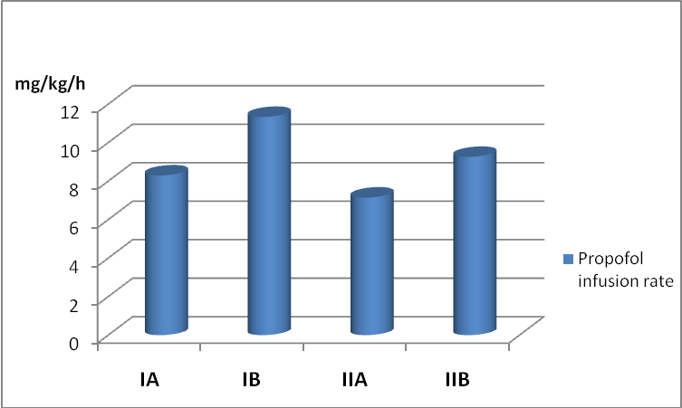
Fig. (28): Propofol infusion rates in group I&II.

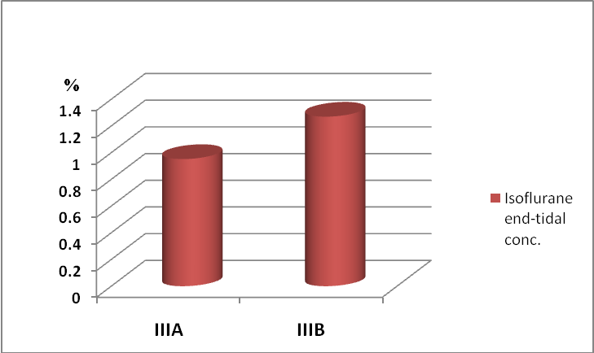
Fig. (29): Isoflurane end-tidal concentration in group III.

Hemodynamics:
In propofol group ( Ι ), mean arterial pressure (MAP) in subgroup A (with BIS ) was higher than in subgroup B (without BIS) (85.61 vs 78.09 mmHg , P < 0.001). Also the heart rate (HR) in subgroup A was higher than in subgroup B (74.32 vs 68.85 bpm, P < 0.001), which is statistically highly significant ( P < 0.001).

In propofol-ketamine group (ΙΙ), MAP in subgroup A (with BIS) was highly significantly lower than in subgroup B (without BIS) (92.61 vs 98.16 mmHg , P < 0.001). While HR was insignificantly lower in subgroup A than in subgroup B (85.82 vs 87.44 bpm, P > 0.05 ).

In isoflurane group (ΙΙΙ), MAP in subgroup A (with BIS) was significantly higher than in subgroup B (without BIS) (90.86 vs 86.90 mmHg , P < 0.001). While HR was significantly lower in subgroup A than subgroup B (76.38 vs 86.44 bpm , P < 0.001), which is statistically highly significant ( P < 0.001).

Among the BIS subgroups (ΙA , ΙΙA , ΙΙΙA) propofol subgroup ( ΙA ) had the lowest MAP and HR.

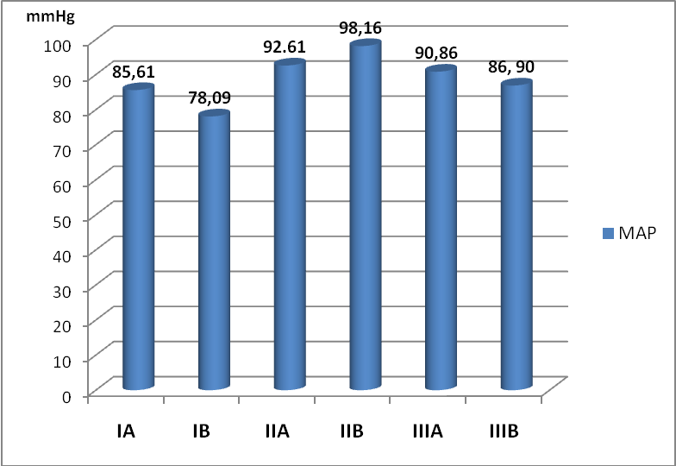
Fig.(30): Different subgroups according to the mean arterial blood pressure(MAP).
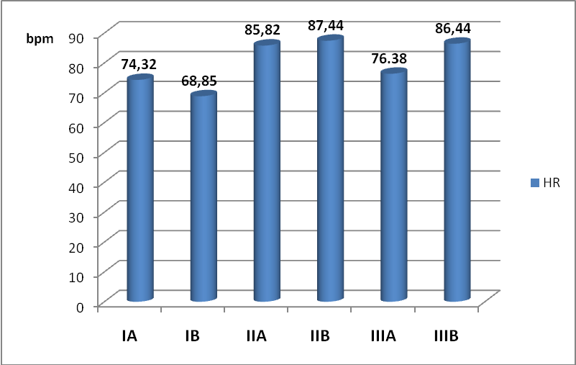
Fig.(31): Different subgroups according to the heart rate (HR).

Recovery profiles:
Spontaneous breathing times were significantly shorter in BIS subgroups (ΙA , ΙΙA , ΙΙΙA) (2.04 , 4.08 , 1.14 min.) than in subgroups without aid of BIS information (ΙB , ΙΙB , ΙΙΙB) ( 4.95 , 6.01, 6.41 min.) respectively, which is statistically highly significant (P value < 0.001) ,with the shortest time being in isoflurane subgroup IIΙA(with BIS ) .
Extubation times were significantly shorter in BIS subgroups (ΙA, ΙΙA, ΙΙΙA) (5.05, 6.995 , 2.63 min.) than in subgroups without aid of BIS (ΙB , ΙΙB , ΙΙΙB) ( 7.02 , 9.98 , 9.05 min.) respectively, which is statistically highly significant (P value < 0.001),with the shortest time being in isoflurane subgroup IIΙA(with BIS).
Times to obey commands (eye opening to verbal command) were significantly shorter in BIS subgroups (ΙA , ΙΙA , ΙΙΙA) (8 , 12.55 , 6.24 min.) than in subgroups without aid of BIS (ΙB , ΙΙB , ΙΙΙB) ( 9.93 , 15.65, 16.13 min.) respectively, which is statistically highly significant (P value < 0.001) ,with the shortest time being in isoflurane subgroup IIΙA(with BIS).
Times to achieve a modified Aldrete score ≥ 9, were significantly shorter in BIS subgroups (ΙA , ΙΙA , ΙΙΙA) (11.29 , 17.2 , 10.35 min.) than in subgroups without aid of BIS (ΙB , ΙΙB , ΙΙΙB) ( 14.41 , 21.35 , 19.90 min.) respectively, which is statistically highly significant (P value < 0.001), with the shortest time being in isoflurane subgroup IIΙA (with BIS ) .
All recovery times were determined at one-minute intervals from discontinuation of anaesthetics.

Table(9):Recovery profiles in propofol group I (IA & IB)
Recovery times (min) | Subgroup IA | Subgroup IB | t | p
Spontaneous breathing | 2.04±0.48 | 4.95±1.26 | 9.6 | <0.001
Extubation | 5.05±0.69 | 7.02±0.76 | 8.6 | <0.001
Obey commands | 8±0.84 | 9.93±1.26 | 5.7 | <0.001
Modified Aldrete≥9 | 11.29±1.17 | 14.41±1.28 | 8.1 | <0.001

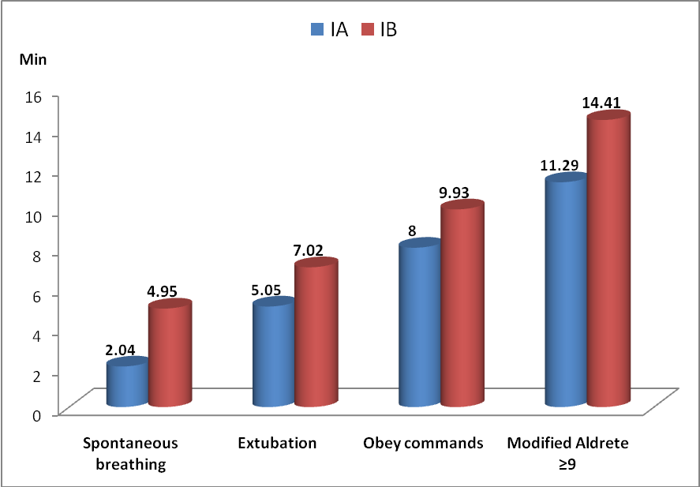
Fig. (32): Recovery profiles in propofol group I (IA & IB).

Table(10):Recovery profiles in propofol-ketamine group II(IIA &IIB)
Recovery times | Subgroup IIA | Subgroup IIB | t | p
Spontaneous breathing | 4.075±1.12 | 6.005±0.69 | 6.6 | <0.001
Extubation | 6.995±0.77 | 9.975±0.9 | 11.2 | <0.001
Obey commands | 12.55±1.77 | 15.65±1.78 | 5.5 | <0.001
Modified Aldrete≥9 | 17.2±1.37 | 21.35±1.98 | 7.7 | <0.001

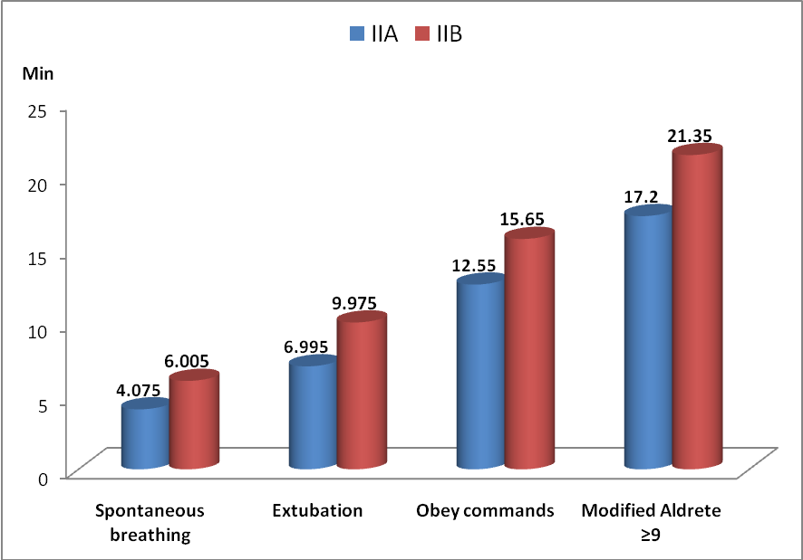
Fig. (33): Recovery profiles in propofol-ketamine group II(IIA &IIB).
Table(11):Recovery profiles in isoflurane group ΙΙΙ (ΙΙΙA & ΙΙΙB).
Recovery times | Subgroup IIIA | Subgroup IIIB | t | p
Spontaneous breathing | 1.14±0.44 | 6.41±0.74 | 27.4 | <0.001
Extubation | 2.63±0.69 | 9.05±1.11 | 22.01 | <0.001
Obey commands | 6.24±0.85 | 16.13±1.7 | 22.9 | <0.001
Modified Aldrete≥9 | 10.35±1.06 | 19.9±2.62 | 15.1 | <0.001

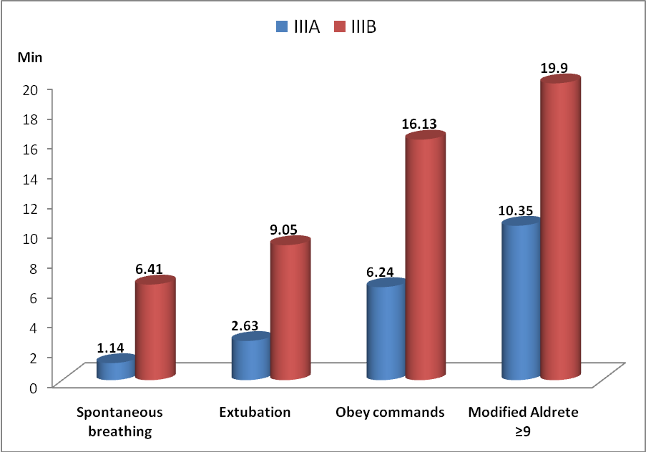
Fig. (34): Recovery profiles in isoflurane group ΙΙΙ (ΙΙΙA & ΙΙΙB).
Table(12):Recovery profiles in BIS-guided subgroups( ΙA & ΙΙA &ΙΙΙA )
Recovery times | Subgroup IA | Subgroup IIA | Subgroup IIIA | f | P
Spontaneous breathing | 2.04±0.48 | 4.08±1.12 | 1.14±0.44 | 81.3 | <0.001
Extubation | 5.05±0.69 | 6.995±0.77 | 2.63±0.69 | 188.5 | <0.001
Obey commands | 8±0.84 | 1.77±12.6 | 0.85±6.24 | 139.6 | <0.001
Modified Aldrete≥9 | 1.17±11.29 | 17.2±1.37 | 10.35±1.06 | 190.2 | <0.001

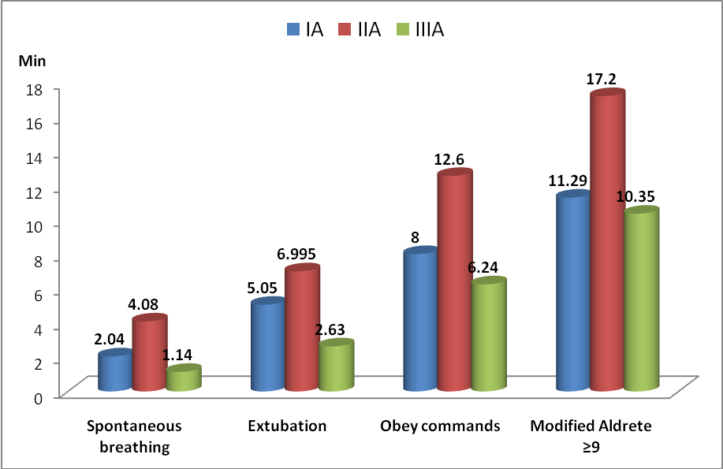
Fig. (35): Recovery profiles in BIS-guided subgroups( ΙA & ΙΙA &ΙΙΙA ).

Awareness:
Patients were questioned for recall of events, hearing vague sounds, feeling surgical instruments or dressing application, or dreaming, and we did not encounter any case of operation-related recall (awareness), in either subgroups.

Postoperative complications:
The incidence of postoperative nausea and vomiting in the first 24 h postoperatively , was lower in BIS subgroups; ΙA (n= 1, 5%) & ΙΙA (n= 0, 0%) & ΙΙΙA (n= 4, 20%) than in subgroups without aid of BIS; ΙB (n= 3, 15%) & ΙΙB(n= 2, 10%) &ΙΙΙB (n= 7, 35%) respectively, but these results did not reach a statistically significant value (P value > 0.05).The least incidence being in propofol-ketamine subgroup ΙΙA(with BIS) ,and the highest incidence being in isoflurane subgroup ΙΙΙB (without BIS). None of the patients of all six subgroups had experienced any hallucinations.

Table (13): Different subgroups according to the postoperative data
 | IA(N=20) | IB(N=20) | IIA(N=20) | IIB(N=20) | IIIA(N=20) | IIIB(N=20)
Awareness | 0 | 0 | 0 | 0 | 0 | 0
PONV | 1 (5%) | 3 (15%) | 0 (0%) | 2 (10%) | 4 (20%) | 7 (35%)
Hallucination | 0 | 0 | 0 | 0 | 0 | 0

